Group A3: Christmas Adventure

# Game Description

The game consists of 4 sections to incrementally improve the Christmassy theme of the house from the main menu.

Each section targets one element of Christmas: Tree, Decorations, Food and Presents.

Each section consists of a platforming part and a subsequent puzzle, which must both be solved, in order, to progress.

In each level, there is the opportunity to collect baubles which add to the decorations in the main menu. You must collect the key to be able to exit the level.

Failing the level will cause you to restart, retaining the keys and baubles that you’ve collected. Failing 3 times will fully restart the level, and you will need to collect the baubles and key again.

Once you’ve completed a level you can go back and replay either part of it again at any time.

Collected Items

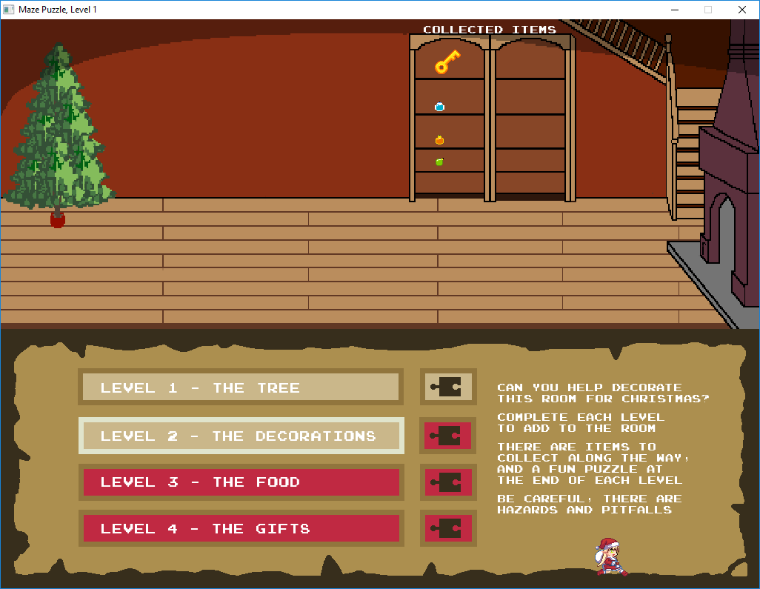

Christmas Room, to be decorated

Game Instructions

Game Menu

**Controls**

Hazard

Bauble

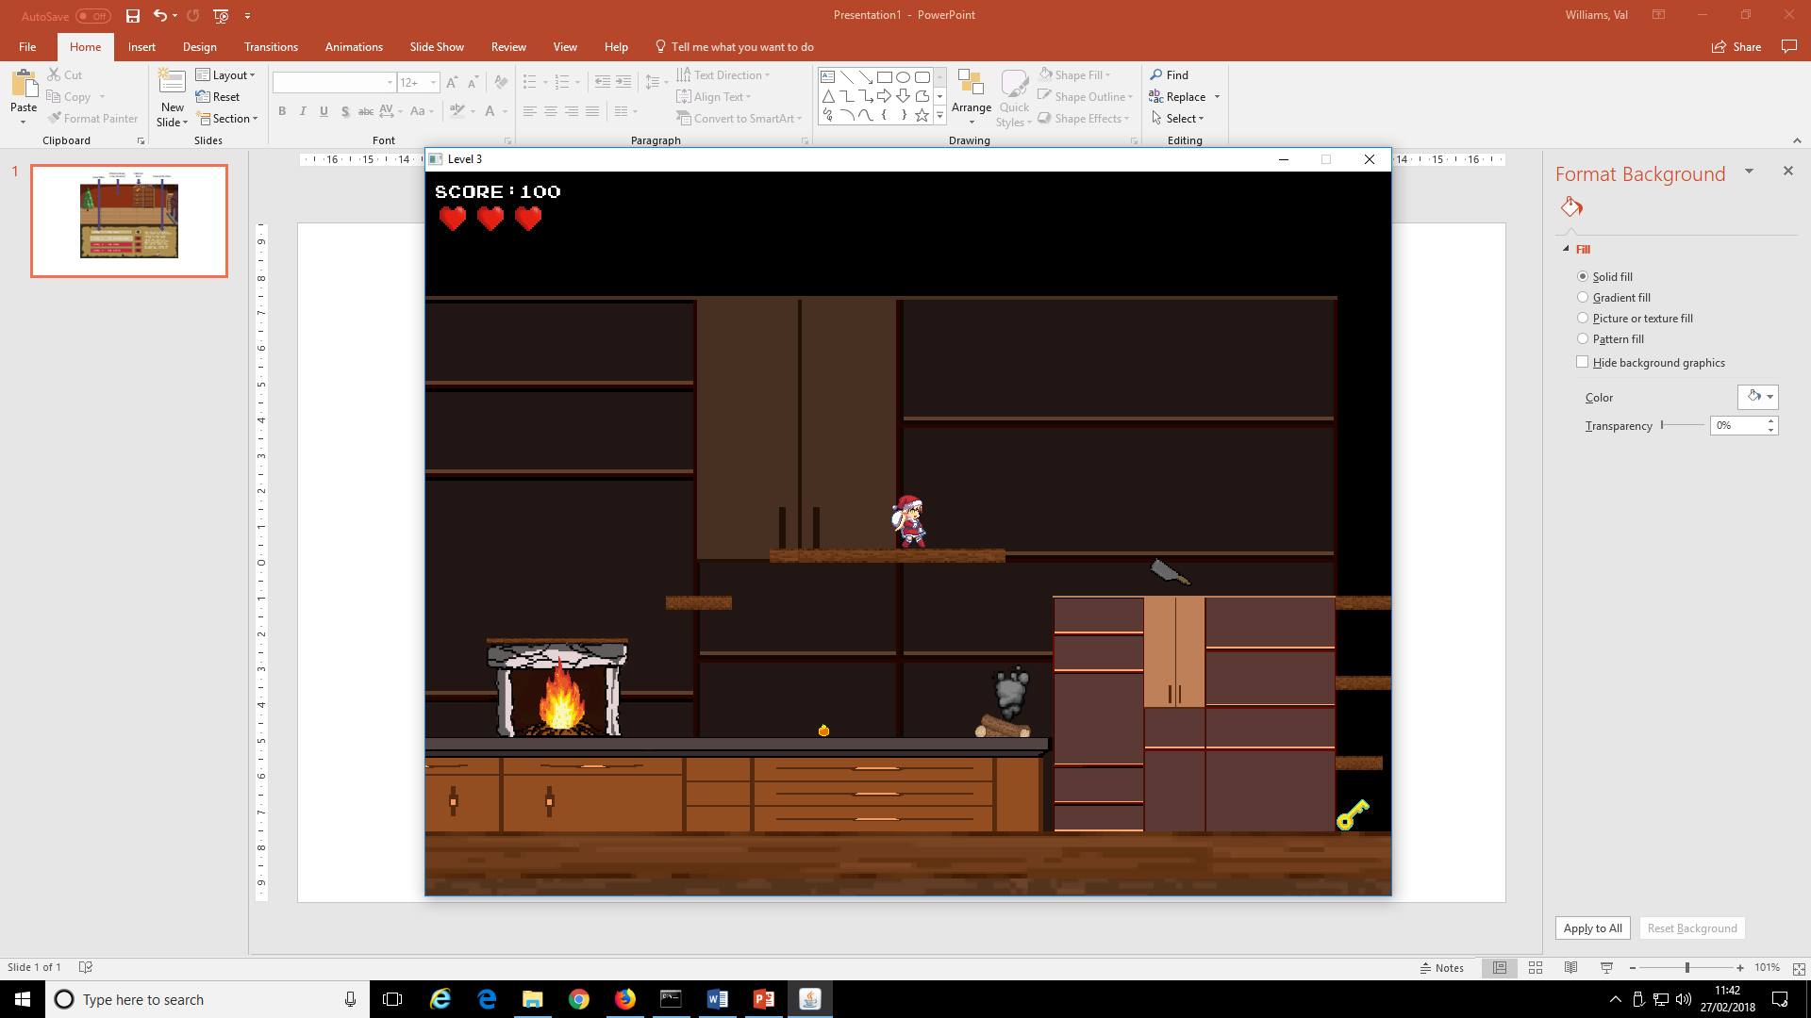

Hazard

Hazard

Key

Platforming:

* WASD or UP/LEFT/DOWN/RIGHT + SPACE controls the player’s movement
* Movement is subject to gravity
* You cannot run through an object. You can jump up onto a narrow shelf from below, but you cannot jump up through a thicker platform (like a brick wall).
* Collect the key to be able to exit at the end of the level – just stand on/next to it; the key flashes to attract attention
* Collect additional baubles in the same way
* Avoid falling down through holes by jumping between platforms; if you fall you will lose a life
* Later levels also have hazards (fire, smoke, cleaver). When these are inactive (smoke/fire off, cleaver down) you can run past them unharmed. When these are active you must avoid them or lose a life.
* Your lives are shown as hearts at the top left. When you lose all your lives, you lose all progress in that platform and go back to the main menu
* In Level4 once you start the sleigh moving it will continue to move until it hits an obstacle or falls off the screen. Use AD (LEFT/RIGHT) to change direction.
* In Level4 the sleigh is flying, but you need to press W (UP) to keep it up in the air, otherwise it will gradually drift down.

Puzzles:

* 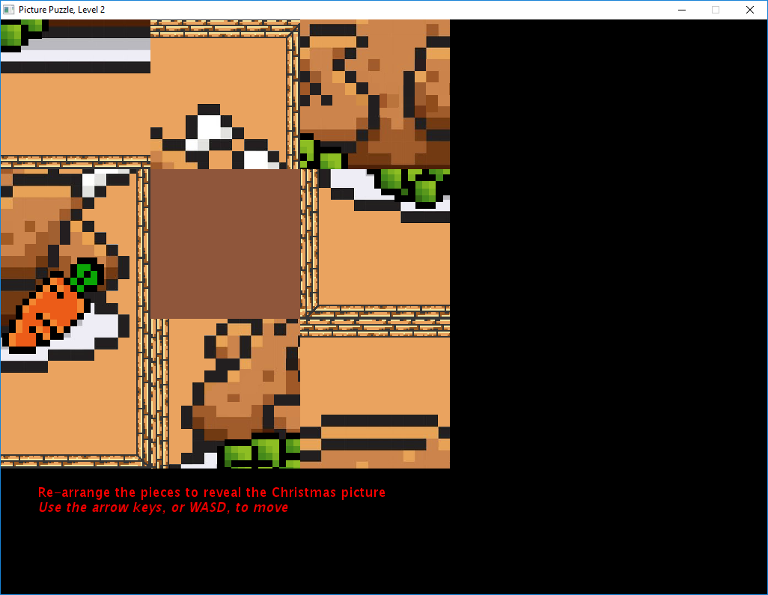WASD or UP/LEFT/DOWN/RIGHT + number keys (1-8) where necessary.
* Maze: get the sprite to the exit
* Christmas Tree Lights: untangle the lights so that each row has one of each colour. Use WS (UP/DOWN) to select the row (the bell will indicate which row is selected). Use AD (LEFT/RIGHT) to rotate that row. The top and bottom rows are static.
* Food Puzzle: just move the pieces to solve the puzzle and see the complete picture
* Sleigh puzzle. Move all the obstacles out of the way so that the sleigh can get to the exit. Select an obstacle using the number keys, then move it using WASD (UP/LEFT/DOWN/RIGHT).